**LAB-2**

**Task#1**

**ls:** lists all files and folders  
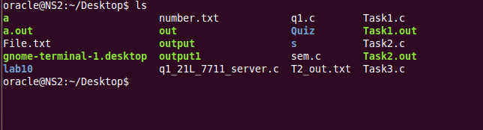

**cd:** to open specific directory 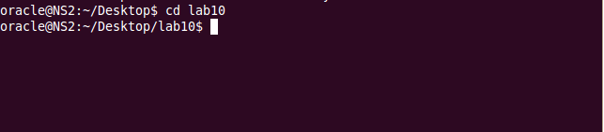

to go to default directory 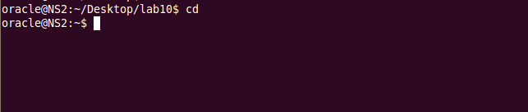

**pwd:** tells the path of current directory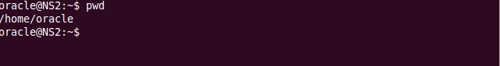

**mkdir:** to make a new directory

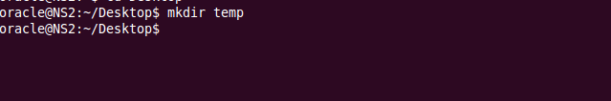

**rmdir:** deletes directory

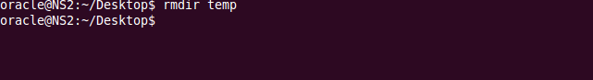

**rm:** to remove files

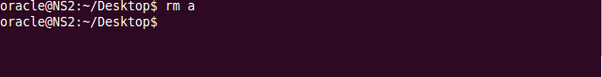

**cp:** to copy file to any folder****

**mv:** to move files from one directory to other

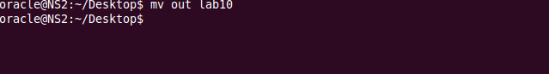

**touch:** to create multiple files

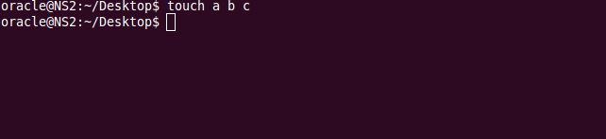

**Task#2**

**top:**

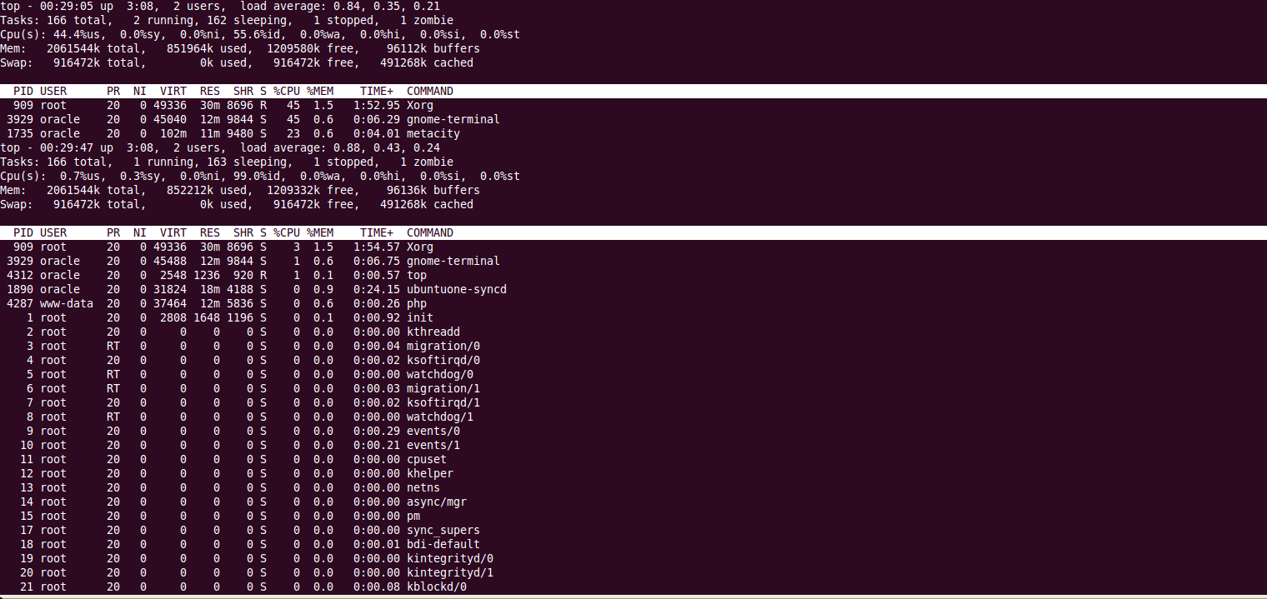

**Ps:**

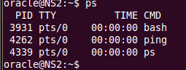

**Kill:**

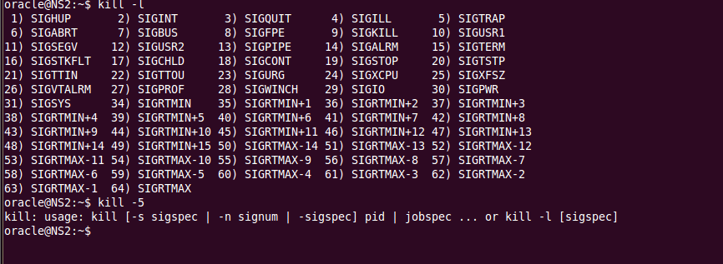

**Chmod:**

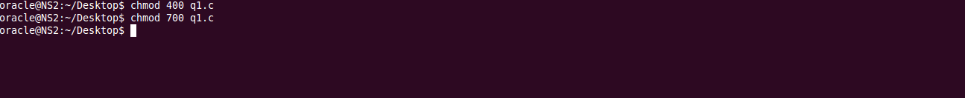

**Ifconfig:**

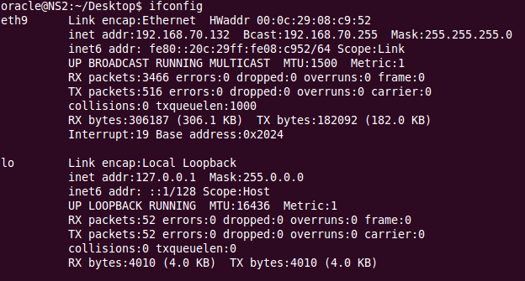

**Route:**

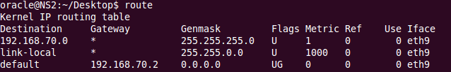

**Ss:**



**Wget:**

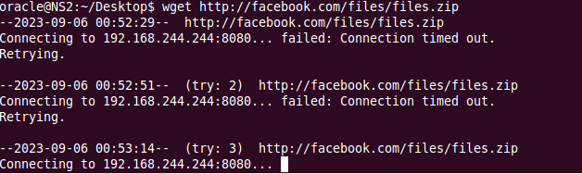

**Traceroute:**

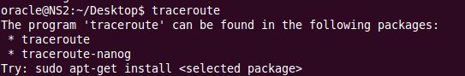

**Nslookup:**

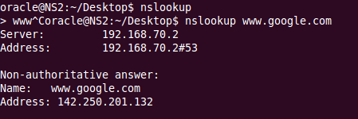

**host:**

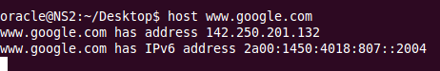

**Task#3**

**Ping:** Ping is a command that is used to check the connection and latency rate between two computers in a network. One network ping another in order to exchange data packets (Response) to calculate the latency and exchange rate.

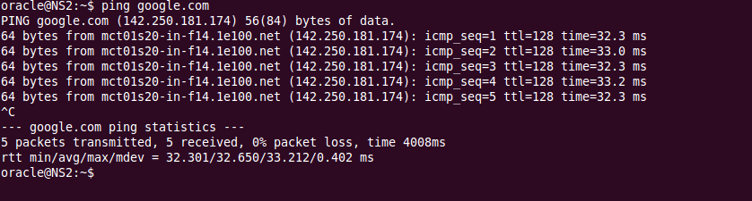

Slowest is 32.3s

Fastest is 33.0s

**Task#4**

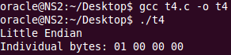

**Code:**

#include <stdio.h>

int main()

{

unsigned int test = 1;

char *byte = (char *)&test;

if (*byte == 1)

{

printf("Little Endian\n");

}

else

{

printf("Big Endian\n");

}

printf("Individual Bytes: %02x %02x %02x %02x\n", byte[0], byte[1], byte[2], byte[3]);

return 0;

}